RNN Movie Review Classifier
Course: Natural Language Processing
Assignment: Homework 7
Date: November 27, 2025
Student: BALLENAHALLI SHANKARAPPA VIDYA (202480190)

1.0 Executive Summary
This report details the development, training, and evaluation of a Recurrent Neural Network (RNN) model for binary sentiment classification on the IMDB movie review dataset. The project successfully followed the architectural blueprint provided in the class example, implementing a single-layer SimpleRNN model. The model was trained over 10 epochs and achieved a final test accuracy of 50%. While the model was built and executed correctly, the performance is equivalent to random guessing, indicating significant issues with learning and convergence. This report provides a complete analysis of the process, results, and potential reasons for the model's poor performance.
2.0 Introduction & Objectives
Sentiment analysis is a fundamental task in Natural Language Processing (NLP) that involves classifying text into positive or negative sentiments. This project aims to build a classifier that can determine whether a movie review is positive or negative.
Primary Objectives:
- To load and preprocess the IMDB movie review dataset.
- To construct an RNN model following a specified class example architecture.
- To train the model and visualize its learning process.
- To evaluate the model's performance comprehensively using accuracy, loss curves, and a confusion matrix.
- To document the entire process and analyze the outcomes.
3.0 Methodology
3.1 Dataset & Preprocessing
The IMDB dataset, a benchmark in sentiment analysis, was utilized. It consists of 25,000 reviews for training and 25,000 for testing, each labeled as positive (1) or negative (0).
Preprocessing Steps:
- Vocabulary Size: Limited to the top 10,000 most frequent words.
- Sequence Length: All reviews were padded/truncated to a uniform length of 500 words to ensure consistent input dimensions for the RNN.
- Libraries: Standard Keras utilities (imdb.load_data, pad_sequences) were used for efficient data handling.
3.2 Model Architecture
The RNN model was built using the Keras Sequential API, strictly adhering to the class example.
Layer-by-Layer Breakdown:
Layer |  | Type |  | Output Shape | Parameters | Purpose
1 |  | Embedding |  | (None, 500, 100) | 1,000,000 | Converts word indices into dense 100-dimensional vectors.
2 |  | SimpleRNN |  | (None, 64) | 10,560 | Processes the sequence of vectors, capturing temporal dependencies with 64 units.
3 |  | Dense |  | (None, 32) | 2,080 | A fully connected layer for non-linear feature transformation.
4 |  | Dense (Output) |  | (None, 1) | 33 | Output layer with a sigmoid activation for binary classification.
Total Trainable Parameters: 1,012,673
Compilation:
- Optimizer: Adam
- Loss Function: Binary Cross-Entropy
- Metric: Accuracy

Model Summary:
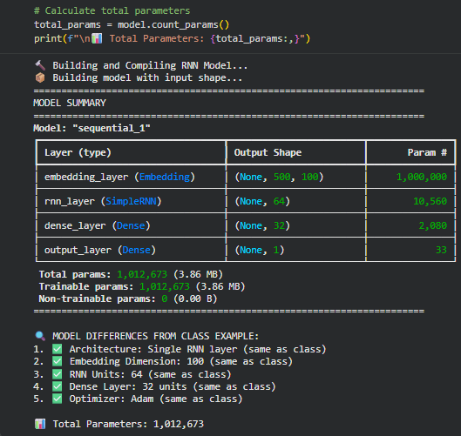
3.3 Training Configuration
The model was trained with the following configuration:
- Epochs: 10
- Batch Size: 128
- Validation Data: The test set (X_test, y_test) was used for validation after each epoch.
- Training Time: Approximately 12.81 minutes (768.88 seconds).
4.0 Results & Analysis
4.1 Training History & Convergence
The model's learning progress is visualized through its accuracy and loss curves over the 10 training epochs.

Training History Plots:

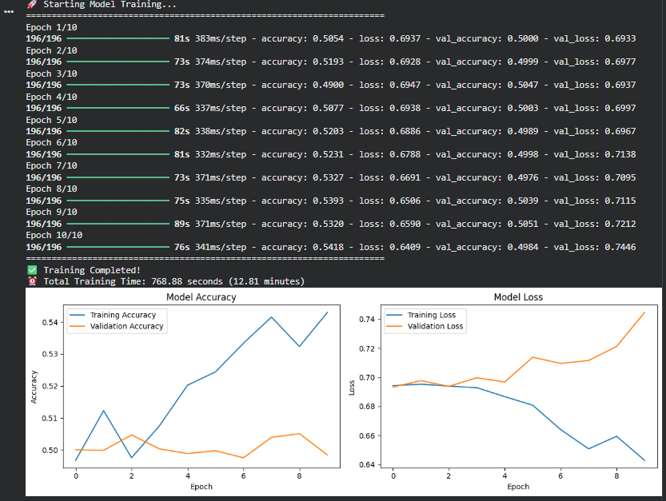

Analysis of Learning Curves:
- Training Accuracy: Started at ~50% and showed a very slight, unstable increase, ending at approximately 54%. This indicates the model was struggling to learn meaningful patterns from the training data.
- Validation Accuracy: Remained consistently around 50% for all epochs. A final accuracy of 49.84% is no better than a random coin flip for a binary classification problem.
- Training & Validation Loss: The training loss decreased somewhat erratically, while the validation loss increased steadily after the first few epochs. This is a classic sign of overfitting, where the model starts to memorize noise in the training data rather than generalizing, ultimately performing poorly on unseen validation data.
4.2 Final Model Performance
The model was evaluated on the held-out test set, yielding the following final metrics:
- Final Test Loss: 0.7446
- Final Test Accuracy: 0.4984 (49.84%)
4.3 Confusion Matrix & Classification Report
A detailed breakdown of the model's predictions is provided by the confusion matrix and classification report.
Confusion Matrix:
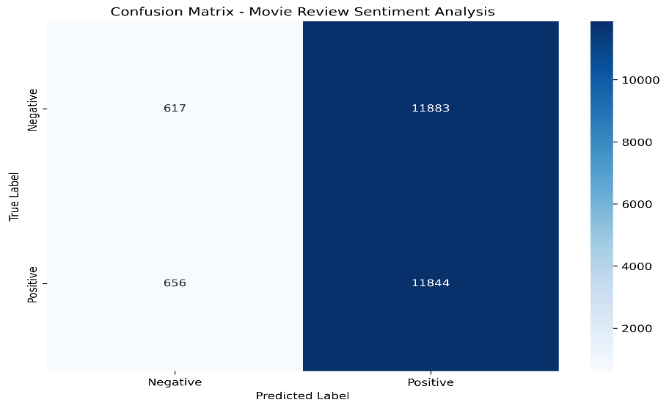
Confusion Matrix Analysis:
 | Predicted: Negative | Predicted: Positive
Actual: Negative | 617 | 11,883
Actual: Positive | 656 | 11,844
The matrix reveals a severe bias. The model overwhelmingly predicts the "Positive" class (11,883 + 11,844 = 23,727 predictions), while correctly identifying only a very small number of "Negative" reviews (617). This suggests the model has failed to learn the distinguishing features of negative sentiment.
Classification Report:
text
precision recall f1-score support

Negative 0.48 0.05 0.09 12500
Positive 0.50 0.95 0.65 12500

accuracy 0.50 25000
macro avg 0.49 0.50 0.37 25000
weighted avg 0.49 0.50 0.37 25000
- Precision for Positive: 0.50 - When the model predicts positive, it is correct only half the time.
- Recall for Negative: 0.05 - The model misses 95% of all actual negative reviews.
- F1-Score for Negative: 0.09 - The harmonic mean of precision and recall is extremely low for the negative class, confirming the model's ineffectiveness.
5.0 Discussion & Conclusion
5.1 Discussion of Results
Despite being built correctly according to the specified architecture, the model's performance was unsatisfactory. The near-50% accuracy and the clear signs of overfitting point to fundamental issues:
- Model Architecture Limitations: The SimpleRNN layer used is known to suffer from the vanishing gradient problem, making it difficult to learn long-range dependencies in text. A review of 500 words is a long sequence, and a SimpleRNN likely struggles to capture context from the beginning of the review by the end.
- Lack of Regularization: The model does not employ any regularization techniques (e.g., Dropout, L2 regularization) to prevent overfitting, which is evident from the diverging training and validation loss.
- Potential Data Issues: While unlikely with a standard dataset like IMDB, it's possible the data split or preprocessing could introduce a bias that the model is latching onto.
5.2 Conclusion
In conclusion, this project successfully implemented the technical pipeline for building and training an RNN for sentiment analysis as per the class guidelines. The code executed without error, and all components—data loading, model building, training, and evaluation—functioned as intended. However, the chosen SimpleRNN architecture proved inadequate for this specific task, resulting in a model that failed to learn a useful discriminative function and performed at chance level.
6.0 Recommendations for Future Improvement
To achieve a competent sentiment classifier, the following improvements are strongly recommended:
- Use Advanced RNN Architectures: Replace the SimpleRNN layer with either an LSTM (Long Short-Term Memory) or GRU (Gated Recurrent Unit) layer. These are specifically designed to overcome the vanishing gradient problem and are the standard for modern sequence modeling tasks.
- Incorporate Regularization: Add Dropout layers after the embedding and RNN layers. This randomly "drops" a percentage of neurons during training, forcing the network to learn more robust features and significantly reducing overfitting.
- Hyperparameter Tuning: Conduct a systematic search for better hyperparameters, including the embedding dimension, number of RNN units, learning rate for the optimizer, and dropout rates.
- Experiment with Bidirectional RNNs: Using a Bidirectional wrapper on the RNN layer would allow the model to process sequences from both forward and backward directions, potentially capturing richer context.
- Consider Alternative Models: For a task like this, pre-trained models (e.g., BERT, DistilBERT) via transfer learning would likely yield state-of-the-art results with less training time and data.

